Division of fractions
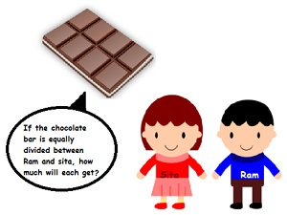

Division of a fraction by a whole number
A fraction being divided by a number is equivalent to the fraction being multiplied by the reciprocal of the number.
A reciprocal of the number is a number which we multiplied by the original number gives1. For e.g. the reciprocal of 2 is ½ since 2*1/2 =1. Similarly, the reciprocal of 7/2 is 2/7.
In short, a reciprocal is obtained by swapping the numerator and denominator.
While dividing mixed fractions by whole numbers, convert the mixed fractions into improper fractions

Division of a whole number by a fraction
To divide a whole number by any fraction, multiply that whole number by the reciprocal of that fraction.
While dividing a whole number by a mixed fraction, first convert the mixed fraction into improper fraction and then solve it.

Division of a fraction by a fraction
In order to the divide, we can multiply the reciprocal of the divisor to the dividend.
The answer obtained is also the answer to the division problem.

Problem: 12 ÷ (3/4)
To divide a whole number by any fraction, multiply that whole number by the reciprocal of that fraction.
The reciprocal of ¾ is 4/3. So,we get:
= 12* 4/3
= 48/3
= 16

(ii) 5 ÷ 3(4/7)
Firstly convert the mixed fraction into improper fraction.(3*7+4)/7 =25/7
To divide a whole number by any fraction, multiply that whole number by the reciprocal of that fraction.
= 5/25/7
= 5*7/25
= 35/25
= 7/5

Problem: Find 7/3 ÷ 2 , 4/9 ÷ 2/3
We will multiply the fraction with the reciprocal of the whole number. The reciprocal of 2 is ½.
= 7/3*1/2
=7/6

4/9 ÷ 2/3
In order to the divide, we can multiply the reciprocal of the divisor to the dividend.
4/9 is the dividend and 2/3 is the divisor.
The reciprocal of 2/3 is 3/2.
= 4/9*3/2
= 12/18
= 2/3 (Dividing by the common factor 6)

